**NGO – Sixty and Better**

**Instruction Manual for Database Operations in**

**MS Access**

**Project Report**

Sharmila Ray

APPLIED-DATABAS-MANAGEMENT– SUMMER-2021

**CONTENTS**

1. **Introduction**
2. **Instructions**
   1. **Section 1: Create Tables, Field, and table Relationship**
   2. **Section 2: Create Query Design and Query Forms**
   3. **Section 3: Create Data Entry Forms for Tables**
   4. **Section 4: Areas of Improvement**
3. **Conclusion**

**INTRODUCTION**

This project aims at building and recommending a better and improved database operations for the NGO – Sixty and Better in MS Access.

The purpose of this project is to first identify the different areas of improvement, second to build an optimal database, third to write queries to request for data from the database and finally to create forms to allow users to both add data to tables through Data entry forms and view data that already exists through query forms.

**INSTRUCTIONS**

**SECTION 1: Create Tables, Fields, and Table Relationship**

The data provided for the project was in a excel spreadsheet Database format which was first analyzed, and the fields were recognized from the registration and survey questionnaires provided along with the database.

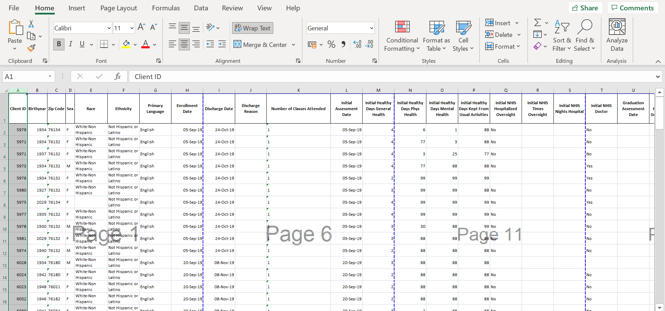

After analysis this spreadsheet was divided into 5 Tables and some additional columns were added to the existing columns in each table, no column was deleted from the original excel spreadsheet. Some synthetic data values were produced to test queries to optimize the database. These values were added in new columns created for the tables.

Each table and columns are created following naming conventions for database objects.

Each table created meet with every rule from 1NF,2NF and 3NF.

Each table have a primary key (i.e., a field that identifies each row with non-null, unique value)

**NOTE:** There was a duplicate entry of ClientID 5975 in the excel spreadsheet, once exported, MS Access eliminated the duplicate entry, keeping the first one in the database.

Some places in the Birthyear Field, a future year of birth was entered in the spreadsheet data which shows negative age when age is derived.

**Table 1**

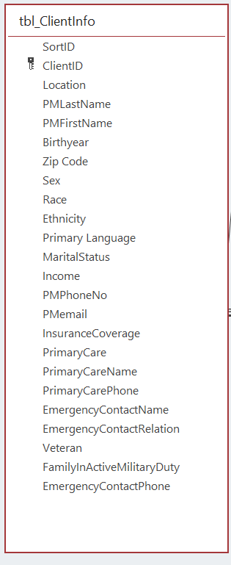

The added columns in Table 1 tbl_ClientInfo are **SortID** created to ensure the original order of the ClientID which is the primary key for ClientInfo table.Other coulmns added are **MaritalStatus**, **Income** as part of the demographic information related to the ClientID’s already collected in the Registration Forms , and **PMPhoneNo**, **PMemail** to contact the Clients, and their **InsuranceCoverage**, **PrimaryCare** if present then the **PrimaryCareName**, **PrimaryCareContact** each collected in the Registration Forms, their **EmergencyContactName**, **EmergencyContactPhone**, **EmergencyContactRelation** and if the Clients are **Veteran** or have **FamilyInactiveMilitaryDuty**. These information’s are paramount to the ClientInfo table in the Database. Some synthetic data were added to the PrimaryCare field.

**Table 2**

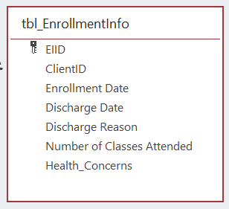

The added columns in Table 2 tbl_EnrollmentInfo are **EIID** and **Health_Concerns**, the EIID is the primary key for the table and the field Health_Concerns is created to test a query based on willingness of Clients to attend future classes because of Health Concerns. We provided some synthetic data in this field.

**Table 3**

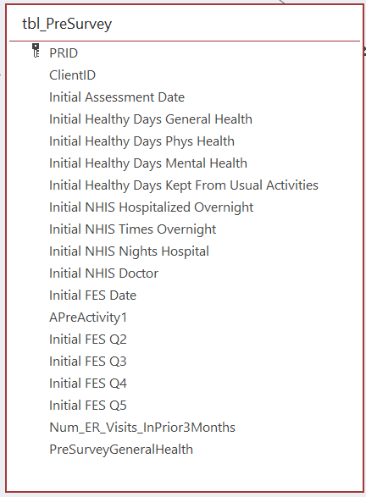

The added columns in Table 3 tbl_PreSurvey are **PRID**, **Num_ER_Visits_InPrior3Months and PreSurveyGeneralHealth,** the PRID is the primary key for the table and the field **PreSurveyGeneralHealth** is created to test a query to evaluate the Clients Pre, Post, and 30 days post Participation general health through the pre-survey and post-survey and 30days post participation survey questionnaire information.

We provided some synthetic data in this field to test the query. Num_ER_Visits_InPrior3Months is created to keep a database of the Client’s number of ER visits before participation in the programs.

**Table 4**

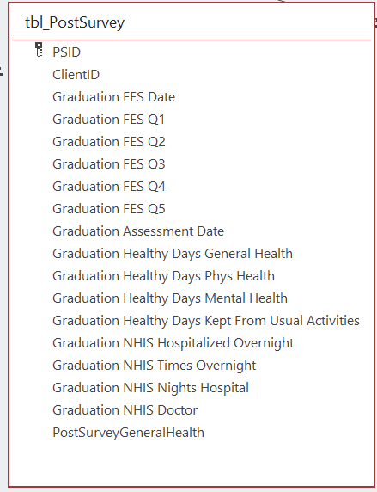

The added columns in Table 4 tbl_PostSurvey are **PSID and PostSurveyGeneralHealth,** the PSID is the primary key for the table and the field **PostSurveyGeneralHealth** is created to test a query to evaluate the Clients Pre, Post, and 30 days post Participation general health through the pre-survey and post-survey and 30days post participation survey questionnaire information.

We provided some synthetic data in this field to test the query.

**Table 5**

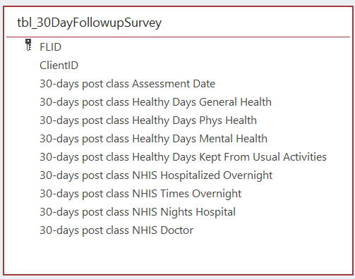

The added column in Table 5 tbl_30DayFollowupSurvey is **FLID,** the FLID is the primary key for the table and the field **30-days post class Healthy Days General Health** has some synthetic data in this field created to test a query to evaluate the Clients Pre, Post, and 30 days post Participation general health through the pre-survey and post-survey and 30days post participation survey questionnaire information.

**Relationship Diagram**

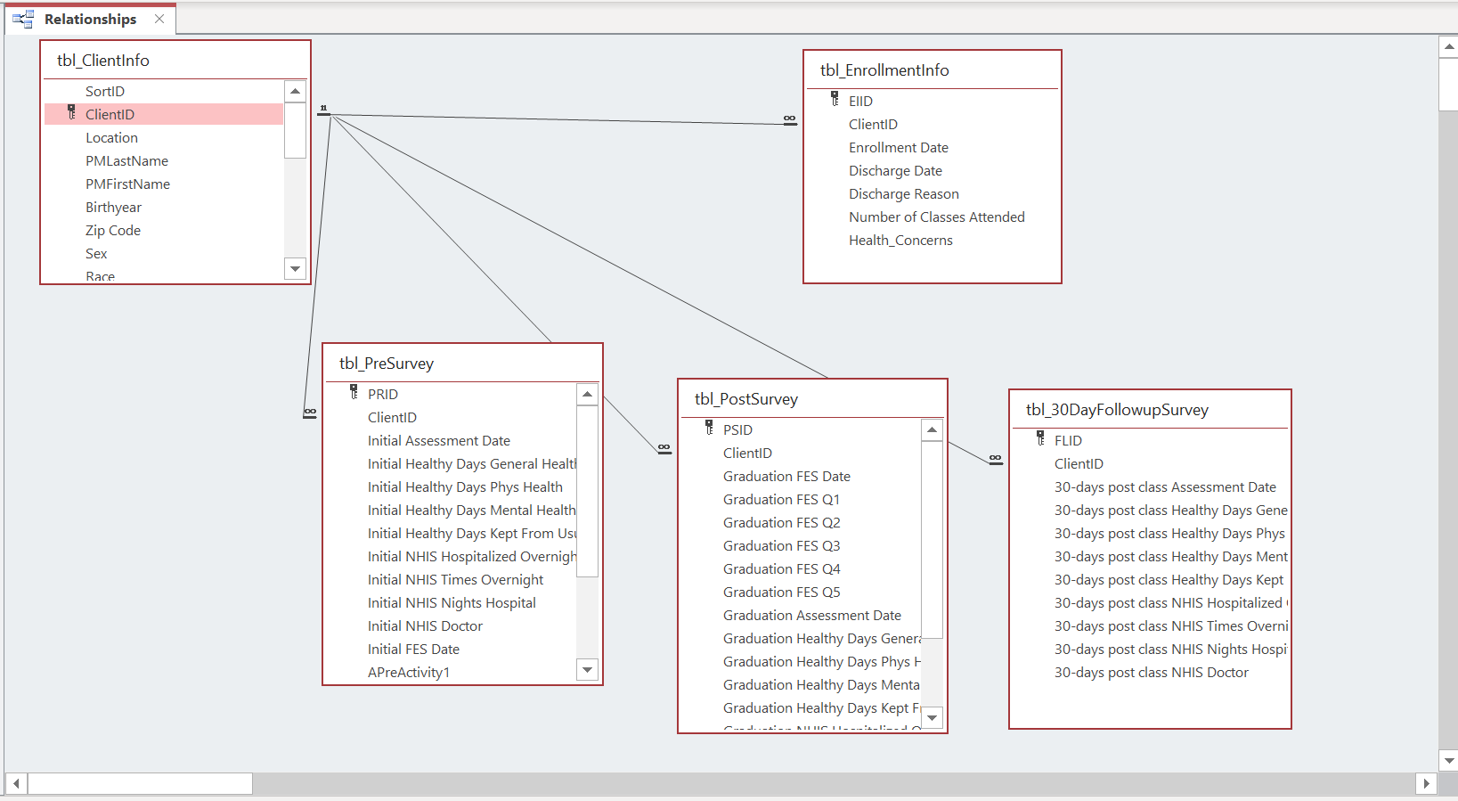

**SECTION 2: Create Query Design and Query Forms**

To request for data from the database some queries are demonstrated below with respective query forms and query designs.

**Query 1**. Provide the health concerns by zip code which can help decision making while trying to set up a particular class in a particular location.

**Query 1 Form:**

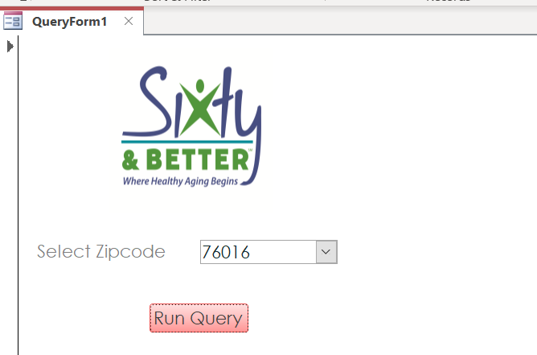

**Query 1 Results:**

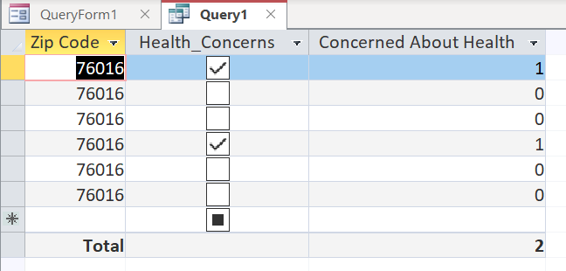

Here, in these results we can see that in zip code 76016 there are 2 participants who are concerned about their health.

**Query 1 Design:**

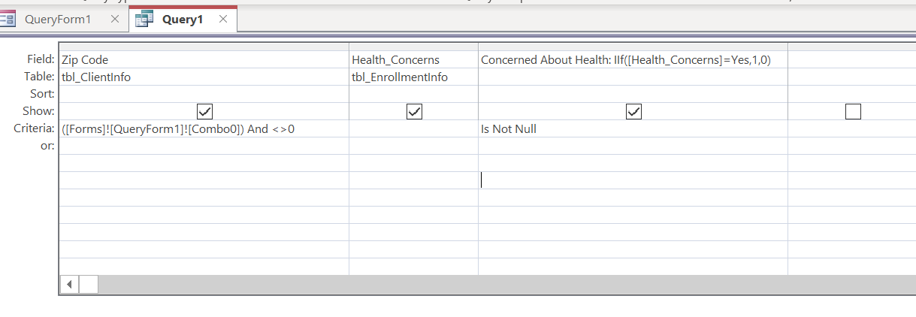

**Query 2**. Provide the number of class participants/graduates by zip code.

**Query 2 Form:**

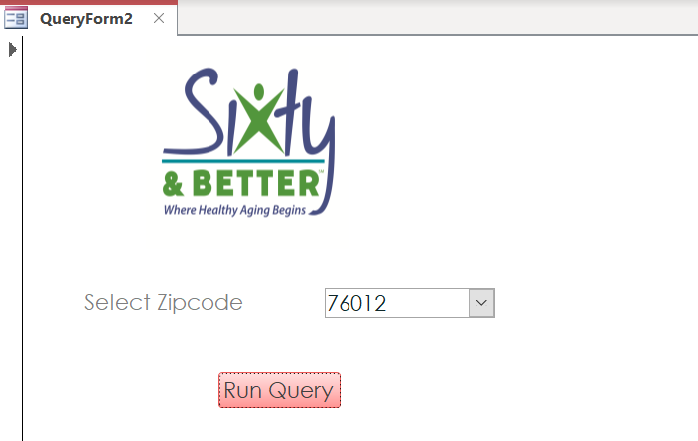

**Query 2 Results:**

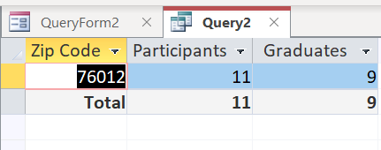

Here, in these results we can see that in zip code 76012 there are 11 participants in total and 9 of them graduated.

**Query 2 Design:**

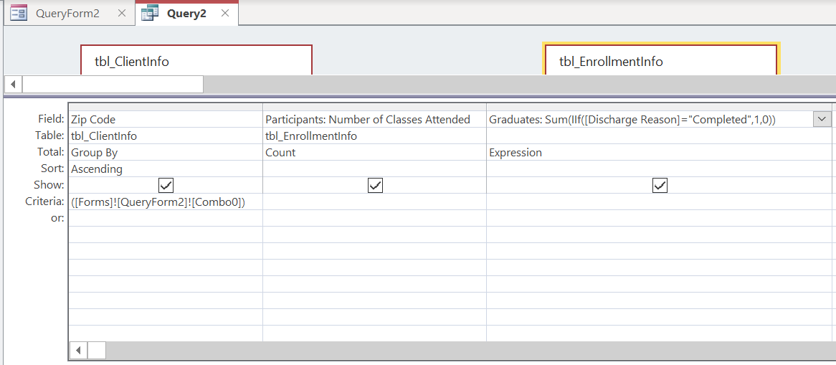

**Query 3**. Provide the number of participants enrolled in a class (AMOB/CDSMP/DSMP), the number of sessions they attended, the number that graduated, and their demographics in a time period.

**Query 3 Form:**

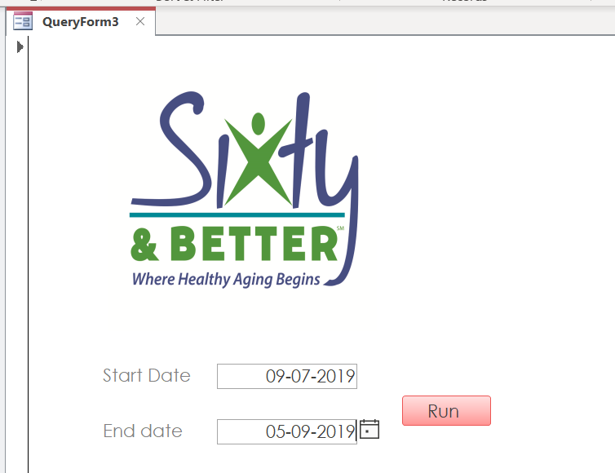

**Query 3 Results:**

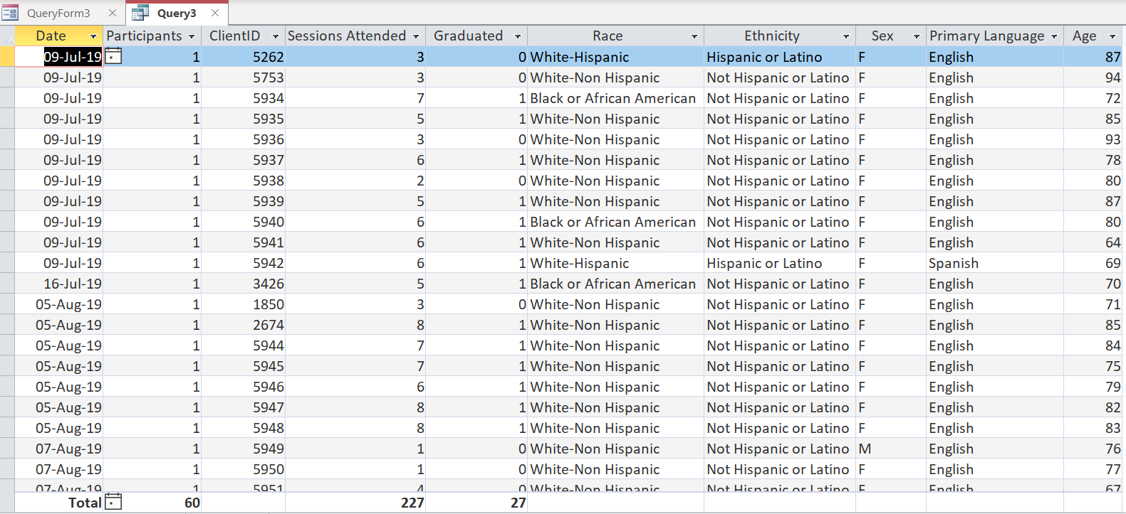

Here, in these results we can see that in between the dates 09-Jul-19 and 05-Sep-19 there are 60 participants in total who attended 227 sessions combined and 27 of them graduated.

**Query 3 Design:**

**Part 1**

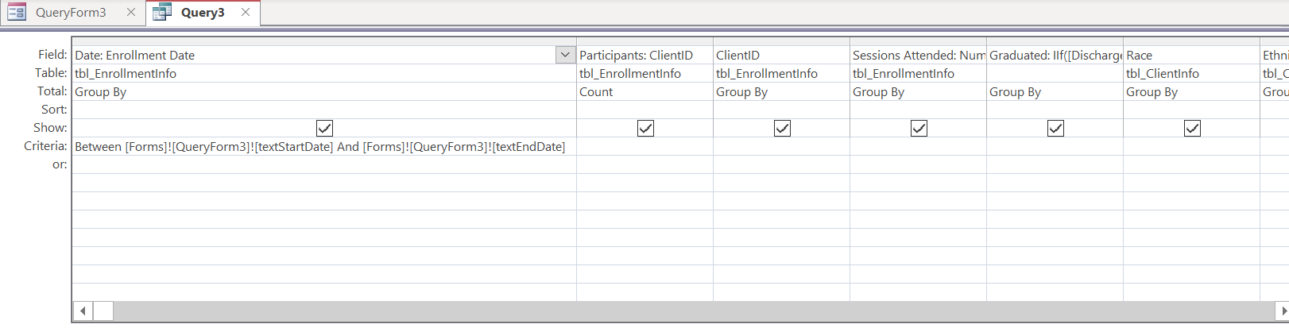

**Part 2**

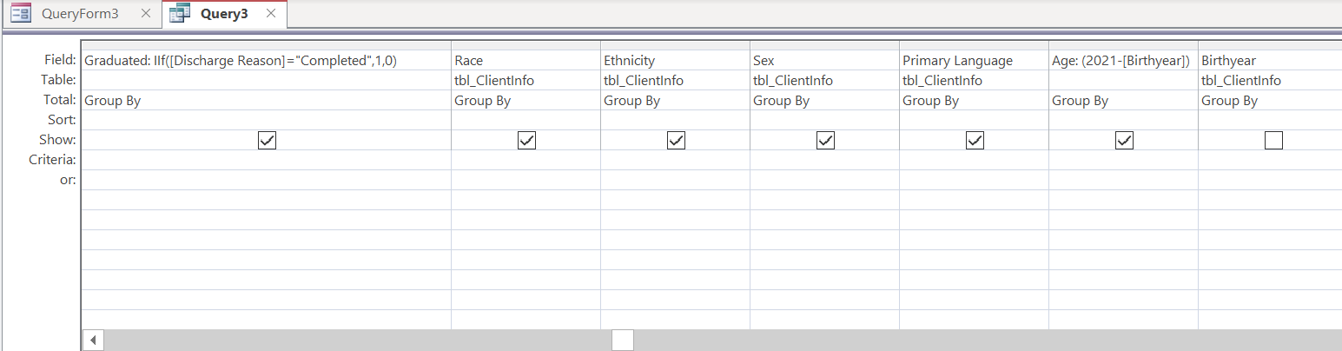

**Query 4**. Provide the general health of the Clients from their Pre, Post, and 30 days post Participation survey’s.

**Query 4 Form:**

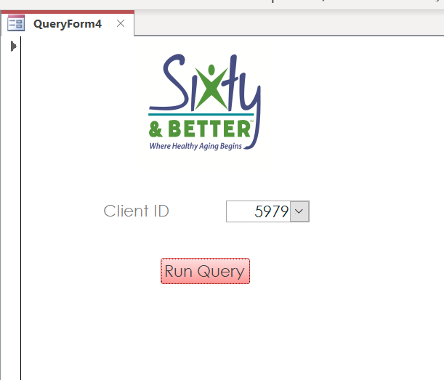

**Query 4 Results:**

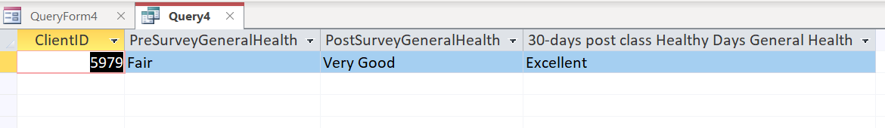

Here, in these results we can see that the Pre, Post, and 30 days post Participation general health for ClientID 5979 are displayed as Fair, Very Good and Excellent respectively.

**Query 4 Design:**

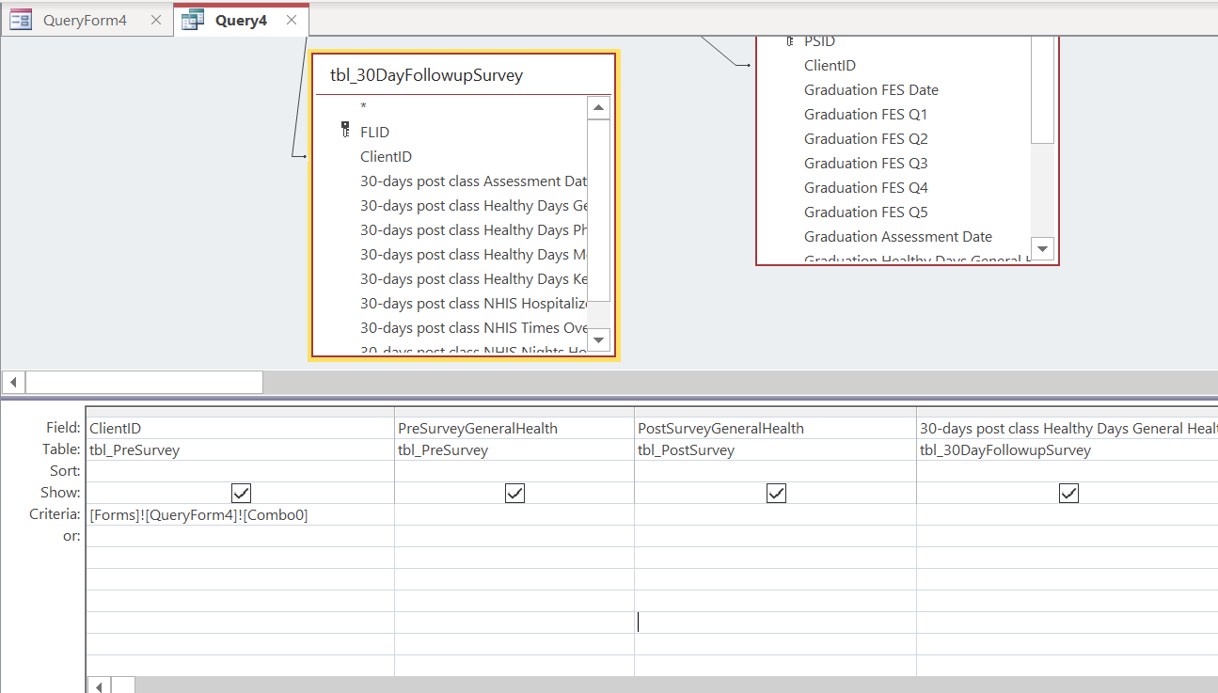

**SECTION 3: Create Data Entry Form for Tables**

The data entry form in the database provides a quick and efficient way to insert and modify records into the database.

Attached below are the data entry forms for each of the tables created for the database.

**Table 1: tbl_ClientInfo Data Entry Form**

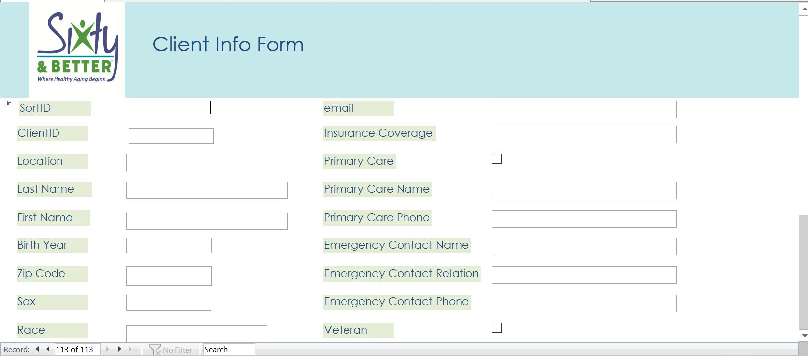

**Table 2: tbl_EnrollmentInfo Data Entry Form**

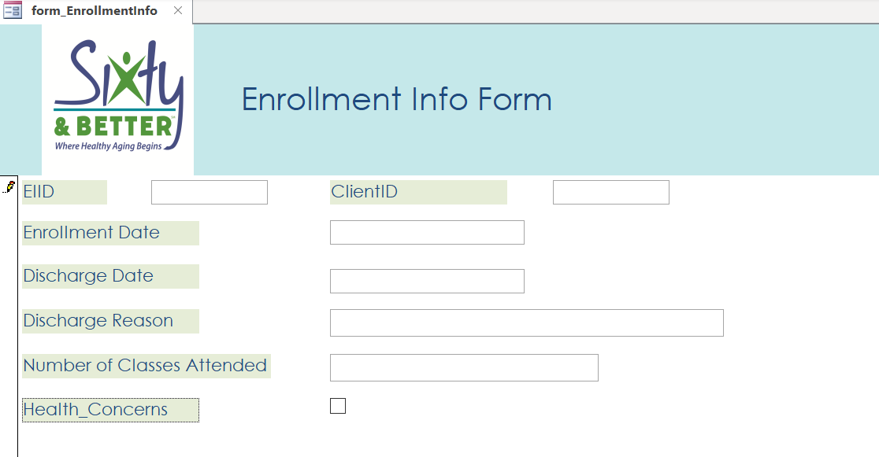

**Table 3: tbl_PreSurvey Data Entry Form**

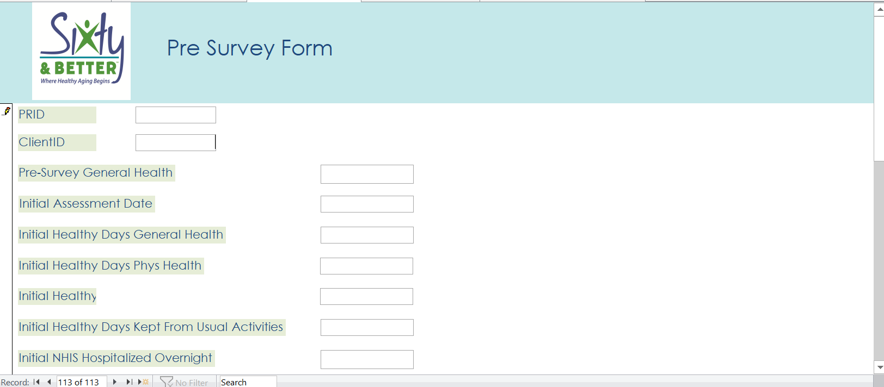

**Table 4: tbl_PostSurvey Data Entry Form**

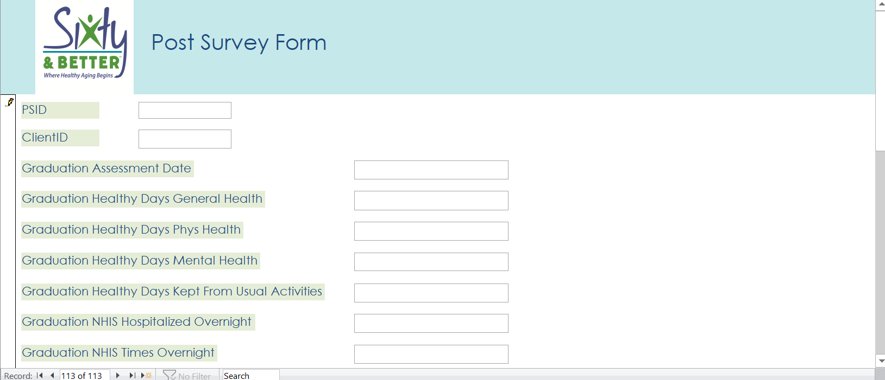

**Table 5: tbl_30dayFollowupSurvey Data Entry Form**

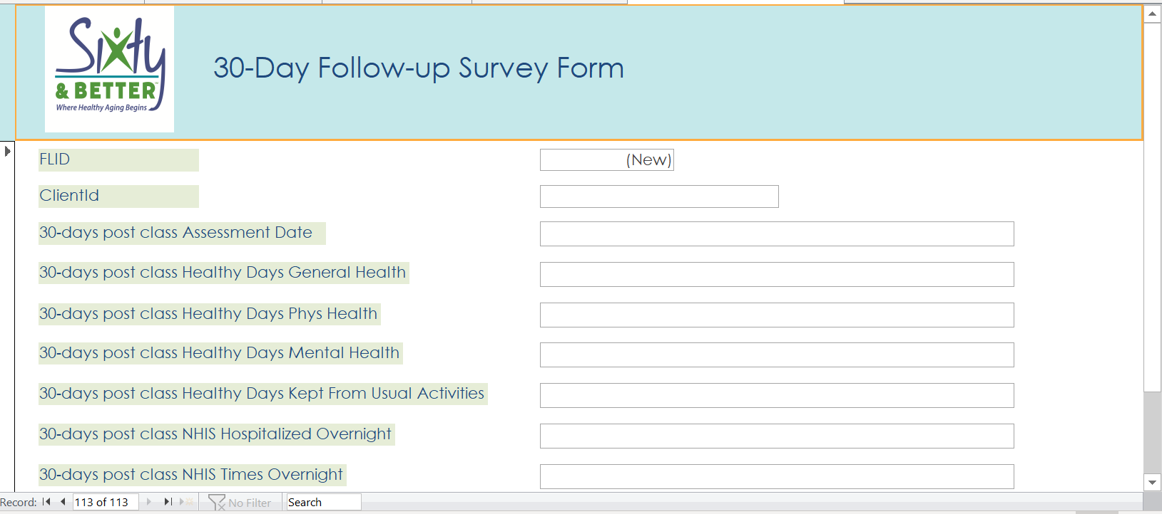

**SECTION 4: Areas of Improvement**

Some of the ways to improve the database of the NGO- Sixty and Better are discussed below.

**CONCLUSION**

The analysis made in the project are instrumental in suggesting an optimal database operation in MS Access for the NGO-Sixty and Better. The recommendations and instructions are within the breadth and scope of Microsoft Access databases. With the aid of the various survey and questionnaire forms and the spreadsheet database and along with basic database knowhow it was possible to create a MS Access database to improve and efficiently perform the operations of a database for the NGO- Sixty and Better.